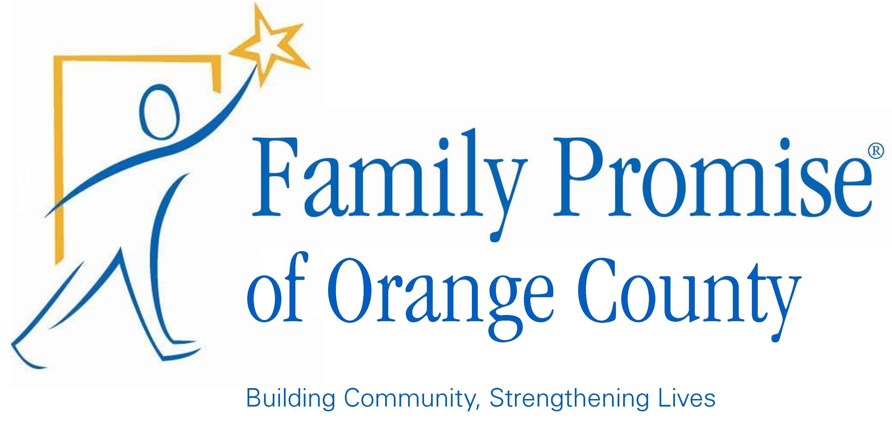

Family Promise of Orange County, Inc.
Community Impact Report 2015

Our Mission: The mission of Family Promise of Orange County is to help homeless families achieve housing stability by providing short term shelter, meals, case-management and hospitality.

Our Vision: We believe that no child should have to sleep in a car, in a park, or under a bridge, and that every family deserves a chance to be whole and have a roof over their head again.

Who We Are:

Family Promise of Orange County (FPOC) is one of 192 affiliates associated with the Family Promise national network of shelters, a nationwide association of agencies that focus specifically on issues relating to family homelessness. With program models based on over 25 years of experience, the organization serves 56,000 family members annually and has assisted over 500,000 individuals return to stable housing since its inception in 1986.

In Orange County, Family Promise began offering services in 2012. Since our launch FPOC has consistently been a top ranking affiliate, both in terms of client success rate and organizational growth. We are committed to providing the best care and individualized assistance to every family that comes through our doors, and to ensuring that all families return to stable housing as quickly as possible. We also continue to offer supportive services to every family that graduates to safeguard that families do not return to homelessness in the future.

Total Program Numbers – 2015

- 127 Individuals served, including 78 children (39 families).
- 88.8% Graduation Rate to Permanent or Transitional Housing.
- Average Stay – 42 Days (Emergency Shelter), 5 Months (Transitional Housing).
- 8175 Bed Nights Provided.
- 9765 Meals Served to Guests.
- 1150 Volunteers Trained and Educated about Family Homelessness.
- Volunteers Logged 11,360 Hours of Support.

Programs

Interfaith Hospitality Network - Emergency Program

Our Interfaith Hospitality Network is a congregationally based response to homelessness. Congregations of
all denominations and faiths open their facilities to homeless families, allowing up to four families at a time to
stay as guests of the faith community. Congregations prepare three meals a day for the families, and
volunteers from the congregations spend their evenings with the families themselves.

Participants in the program also receive comprehensive, individualized case management at our Family
Resource Center in Orange, CA. This includes but is not limited to job and credit counseling, resume writing,
welfare advocacy, legal services, and family and individual therapy.

Enjoying the support of wrap-around care as well as the hospitality of the congregation, participant families
typically return to full independence within 2-3 months.

Category
Emergency Shelter/Interim Housing
Public Education - Homelessness

Program Short-Term Success
*A minimum of 75 individuals (20 families) will be served in a calendar year.
*Families will return to stable housing within 60 days of entering the shelter program.
*While in the program families will remain drug and alcohol free.
*Families will save 80% of income after paying needed expenses.
*Children will stay enrolled or re-enroll in public school.
*Host and Support congregations will provide daily meals and provide hospitality and support to program
Guests.
*A minimum of 750 volunteers will receive education and training about family homelessness in Orange County.

Program Long-Term Success
*A minimum of 80% of program families will return to and remain in stable, long-term housing.
Program Success Monitored By
The Board of Directors oversees all aspects of operations at Family Promise. The Executive Director reports
program updates to the board on a weekly basis. Program staff track all aspects of case-management,
including:

*Demographics of shelter guests and residents -- race, ethnicity, age, income and education level.
*Length of stay in shelter.
*Type of housing secured upon graduation.
*Confirmation of drug tests taken.
*What % of each family's case management goals were achieved.
*Confirmation of children's enrollment in school & ongoing participation in school activities.
*Training on family homelessness led by Family Promise staff and/or trained congregation coordinators.

Examples of Program Success - 2015
*82 Individuals served, including 49 children (25 families)
*90.91% of families graduated into permanent or transitional housing.
*Average length of stay was 42 days.
*3325 bed nights and 9765 meals provided by host and support congregations.
*86% of case management goals attained by client families.
*2058 school days were preserved.
*750 volunteers received training and logged approximately 10,500 volunteer hours

Jacob's House Transitional Housing Program

Jacob's House offers transitional, low-cost housing for homeless families for up to six months. Families who
participate in the program must be employed, and agree to both pay back debts and/or save 80% of all income
earned while in the program after expenses. Families will have the same case-management support available to them as in our congregational program, including but not limited to job and credit counseling, resume tutoring, legal services, and individual and family therapy.

Category
Transitional Housing

Program Short-Term Success
*Program Participants will meet monthly savings goals.
*Program Participants will return to permanent housing within 6 months.
Program Long-Term Success
*Serve 8-10 families each calendar year.
*90% of program participants will return to and remain in market housing.
*Program participants will return to market housing having freed themselves of a substantial portion of their
debt.

Program Success Monitored By
The board of directors oversees all aspects of operations at Family Promise. The Executive Director reports
program updates to the board on a weekly basis. Program staff track all aspects of case-management,
including:

*Demographics of shelter guests and residents -- race, ethnicity, age, income and education level, history of
trauma/abuse, substance use/abuse.
*Length of stay in housing.
*Type of housing secured upon graduation.
*Confirmation of drug tests taken.
* What % of each family's case-management goals were achieved.
* Confirmation of children's enrollment in school.
* Verification of family saving goals.
Examples of Program Success - 2015
*45 Individuals served, including 29 children (14 families).
*Average length of stay was 151 Days (5 Months, 1 Day).
*85.7% of families graduated into permanent housing.
*90% of case management goals completed.
*4850 bed nights provided to families.
*Families paid off an average of $4221 in debt while in the program.
*Over the last two years, 91% of our graduates have remained in stable housing.

Family Promise Supplemental Food & Cooking Program

Category
Food Insecurity
Food Education
Guest Aftercare

Family Promise currently offers food services to families in three ways:
1) Cooking Classes: We provide 6 months of cooking and food budgeting classes to the families currently participating in our Jacob’s House transitional program. These classes are co-taught by a Social Worker and a professional chef with a culinary arts degree. The aim of the class is that clients will be able to eat well on a very limited budget. To that end, clients learn how to prepare delicious and nutritious meals for under $2.00 a plate.
Program Outputs: Upon completion of the program clients will be able to:
*Prepare a food budget.
*Read food labels.
*Use local food pantries in their meal planning.
*Understand food unit pricing.
*Understand the basics of food safety and meal preparation.
*Be able to prepare several meals in under 30 minutes.

In 2015: 14 families participated in the program. Of these, 12 completed the program, and were able to pass a competency test at the end of their time in the program.

2) Grocery Street Outreach – Once monthly Family Promise disperses groceries to approximately 50 individuals in downtown Orange via a public event partnering with First Presbyterian Church of Orange and the YWCA. The program is designed as an outreach tool to connect with homeless families, although no one is turned away. The meal provides us a regular connection with local low-income/homeless families, and an initial point of contact for those seeking assistance.
Program Outputs: In any given month, 50+ individuals will be provided groceries and information about Family Promise.
In 2015: 452 individuals received groceries
3) Supplemental Groceries for Graduates – We provide ongoing grocery support for families reporting food insecurity once they return to housing from either our emergency or transitional programs. Families who report insecurity can receive bi-weekly groceries from our Food Pantry. This both assists families who are on tight financial budgets, and incentivizes families to keep contact with Family Promise post-graduation.
Program Outputs: Participating families report greater food security and keep in regular communication with Family Promise.
In 2015: 21 families participated in the program. All reported greater food security. Family contact (post-graduation) has increased 22% since the program began.

